

DATA COMMUNICATION AND NETWORKS
(FINAL LAB PROJECT)

COMPANY NETWORK DESIGN

Members:
Ambreen Naeem
Sameea Amjad
Sadaf Fatima

Contents

Introduction 1
01

02
Objectives Achieved 1

Network Design Approach 1
03

Logical Network Design 2
04

05
Routing and Connectivity 3

Network Services Implementation 6

06

07
Wireless Network Design 7

Network Security Implementation 8

08
Conclusion 11
Future Enhancements 12
Testing and Verification 10
Device Configuration Standards 9
12
11
10
09

01

Introduction

Enterprise networks are the backbone of modern organizations, enabling reliable communication, data transfer, and internet connectivity across multiple departments and geographical locations. This project focuses on designing and implementing a scalable, secure, and robust network infrastructure suitable for medium to large organizations.
The design follows industry best practices, including hierarchical network architecture, VLAN segmentation, IP subnetting, redundancy, security measures, and dynamic routing, ensuring optimal performance and manageability.
02

Objectives Achieved

The primary objectives of this network design project were:
- To design a structured enterprise network using a hierarchical model.
- To implement logical segmentation using VLANs.
- To efficiently allocate IP addresses using subnetting techniques.
- To provide redundant internet connectivity.
- To enable inter-VLAN communication through Layer 3 routing.
- To deploy wired and wireless access across the network.
- To implement security controls for device access and traffic filtering.
A
C
D
- To validate the network through functional testing.

Network Design Principles
03

3.1 Hierarchical Network Design

The network is designed using the three-tier hierarchical model:
- Core Layer: Responsible for high-speed routing and connectivity to external networks (ISPs). Redundant routers are deployed to ensure high availability.
- Distribution Layer: Implemented using multilayer switches to handle inter-VLAN routing, policy enforcement, and traffic aggregation.
- Access Layer: Provides connectivity to end devices and wireless access points. Port-level security is applied at this layer.
This structure simplifies troubleshooting, allows independent expansion of network sections, and improves performance.

Network Diagram:

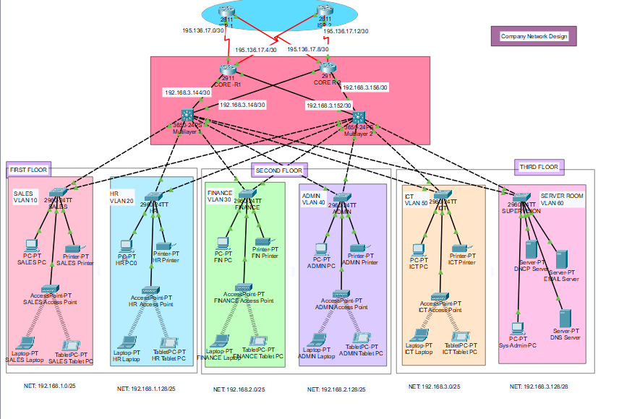

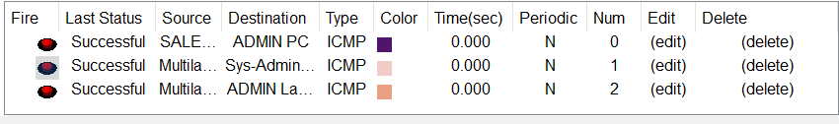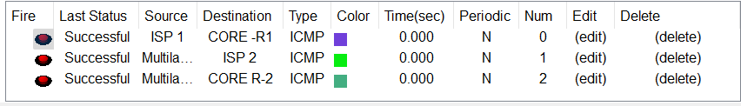

04

Logical Network Design

4.1 Network Segmentation with VLANs

VLANs were implemented to logically separate traffic based on function. This improves security, reduces broadcast traffic, and enhances performance.

VLAN ID | Department Name
10 | Sales
20 | HR
30 | Finance
40 | Admin
50 | ICT
60 | Server Room

Each VLAN is mapped to a unique IP subnet and routed via multilayer switches. For this purpose a private IP addressing scheme based on the 192.168.0.0/16 range was selected and carefully subnetted into multiple /25 and /28 networks to logically separate each VLAN. This subnetting approach provides sufficient host capacity for wired and wireless devices within each functional group while minimizing IP address wastage and maintaining clear network segmentation.

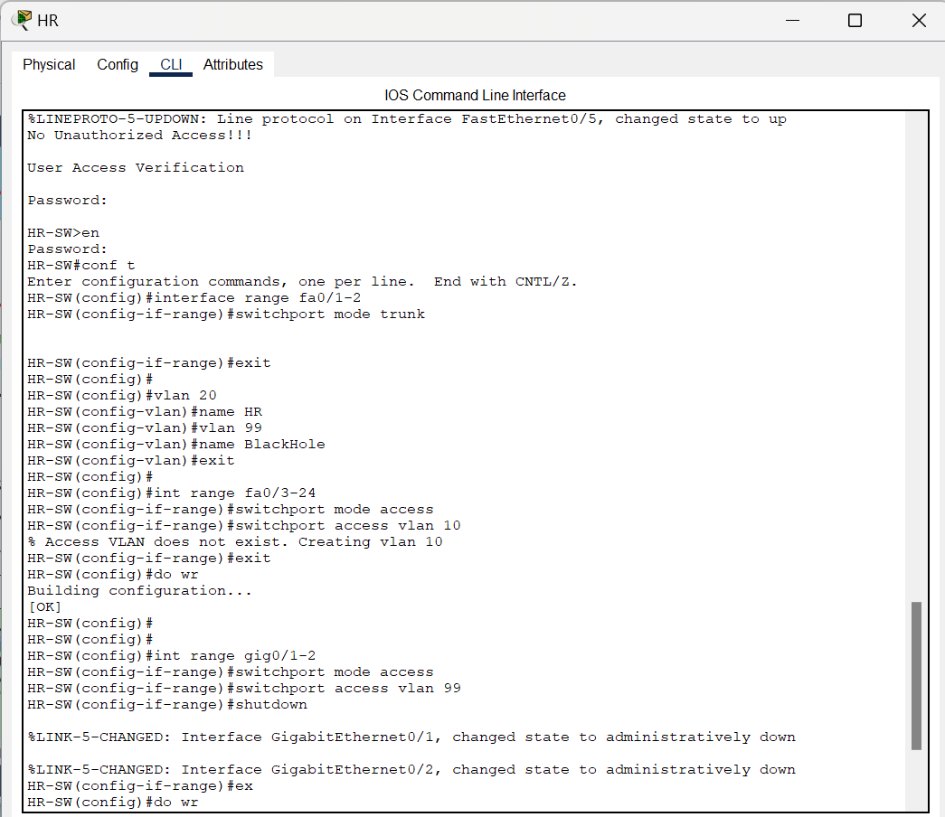

05

Routing and Connectivity

5.1 Inter-VLAN Routing

Inter-VLAN communication is achieved using Layer 3 switching. Switched Virtual Interfaces (SVIs) were configured for each VLAN, allowing efficient routing without external routers.

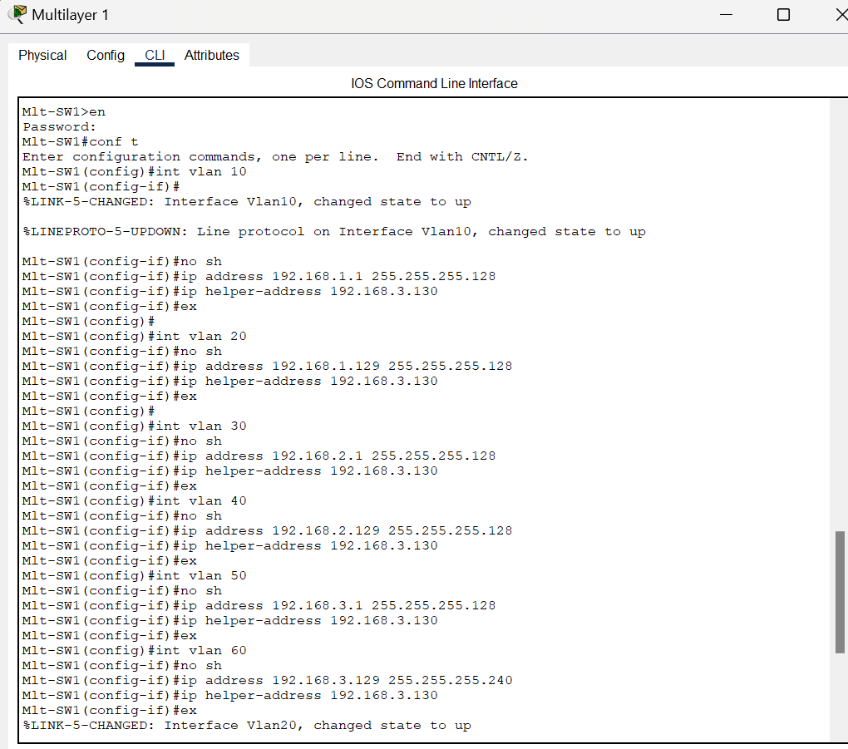

5.2 Dynamic Routing Protocol

OSPF (Open Shortest Path First) was selected as the internal routing protocol due to:
- Fast convergence
- Scalability
- Open standard compatibility
All routers and multilayer switches participate in the same OSPF area, enabling automatic route advertisement and redundancy.

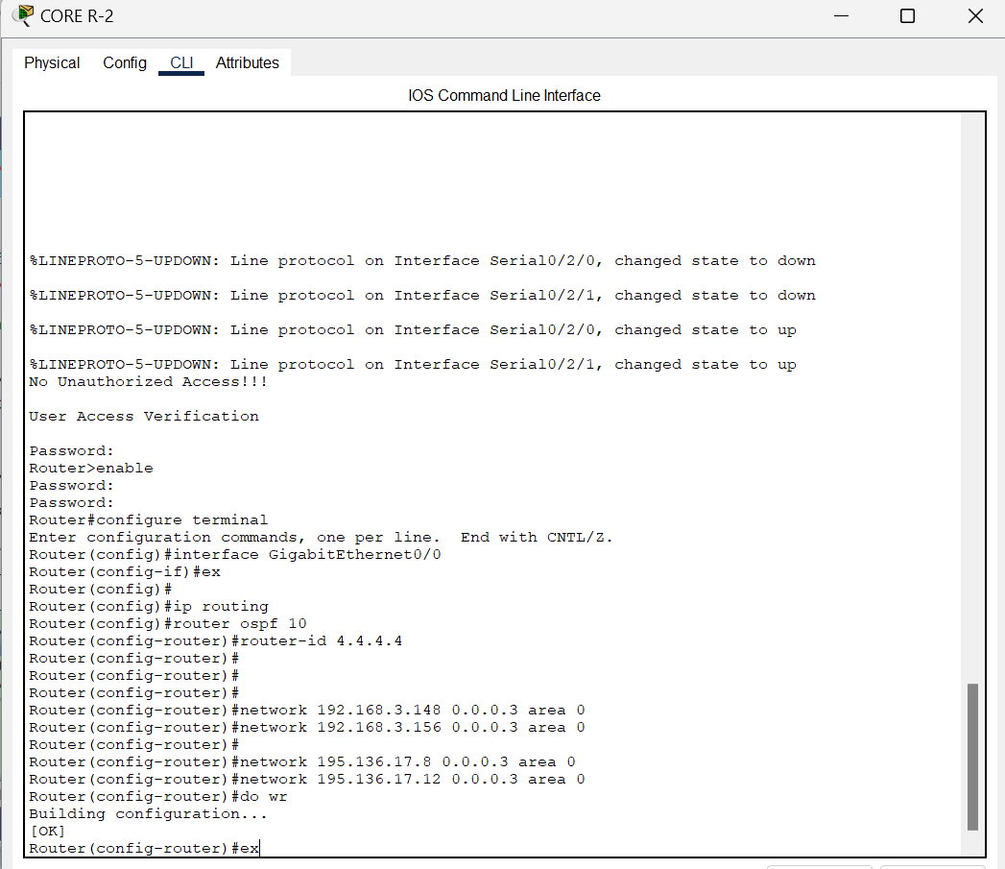

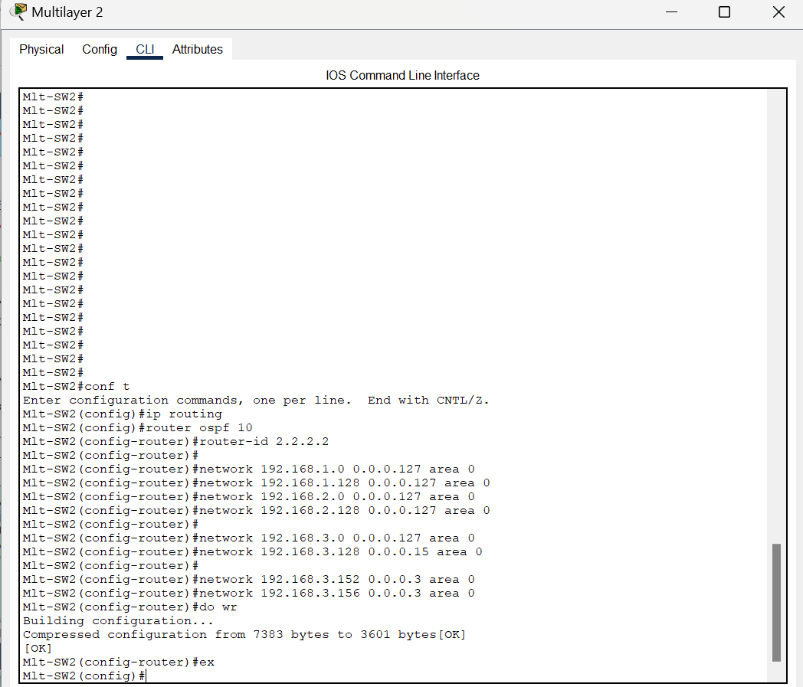

5.3 Internet Connectivity and Redundancy
To ensure uninterrupted external access:
- Two routers are connected to multiple ISP links
- Public IP subnets are assigned to WAN interfaces
- Redundancy ensures failover in case one ISP link becomes unavailable

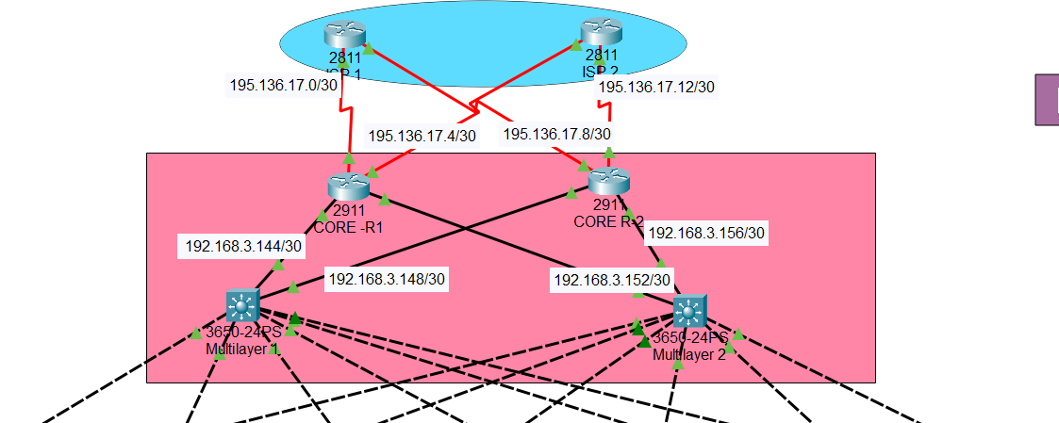

06

Network Services Implementation

6.1 DHCP

A centralized DHCP service was implemented to:
- Automatically assign IP addresses to hosts
- Reduce configuration errors
- Simplify network administration
Separate DHCP pools were created for each VLAN with appropriate default gateways and DNS settings.

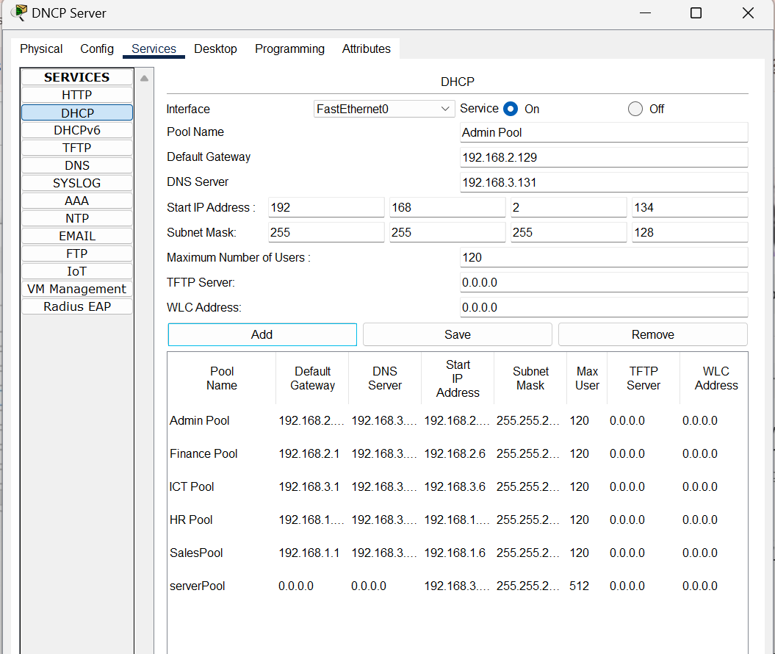

6.2 PAT

Port Address Translation (PAT) was implemented on edge routers to:
- Allow internal private IP addresses to access the internet
- Conserve public IP addresses
- Add a layer of security by hiding internal network structure

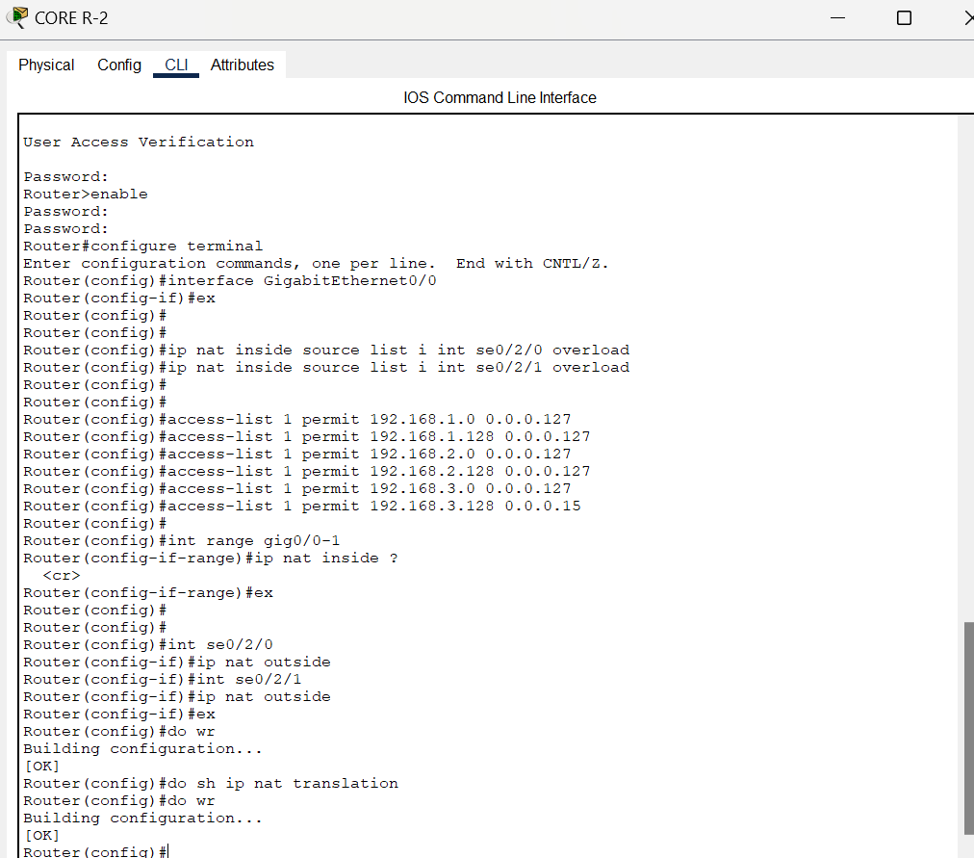

07

Wireless Network Design

Wireless access was integrated to support mobility and ease of access.

Key decisions:
- Each access point is mapped to a specific VLAN
- Wireless traffic follows the same logical segmentation as wired users
- Security protocols are applied to prevent unauthorized access
This ensures consistent policy enforcement across wired and wireless networks.

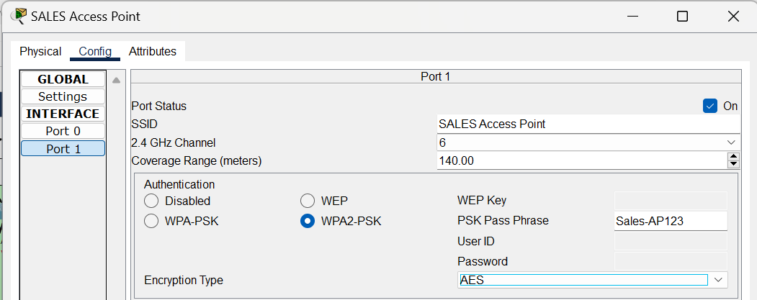

08

Network Security Implementation

Security was applied at multiple layers:
8.1 Port Security

- Restricts the number of devices per switch port
- Uses sticky MAC address learning
- Automatically shuts down ports on violations

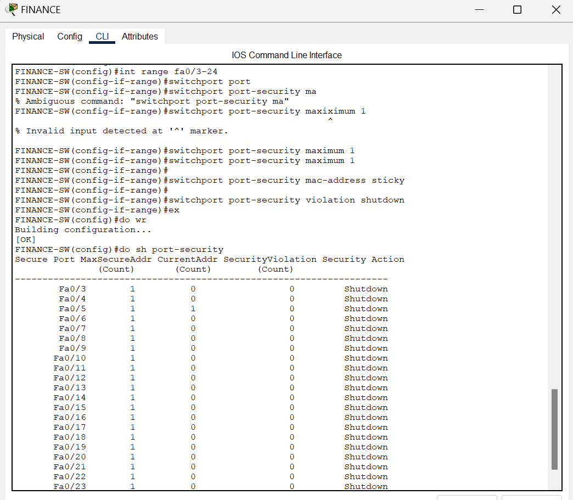

8.2 Access Control Lists (ACLs)

- Control traffic flow between VLANs
- Restrict access to sensitive network segments
- Limit unnecessary inter-department communication
8.3 Secure Device Management

- SSH is used for remote device access
- Console and privileged passwords are configured
- Login banners are applied
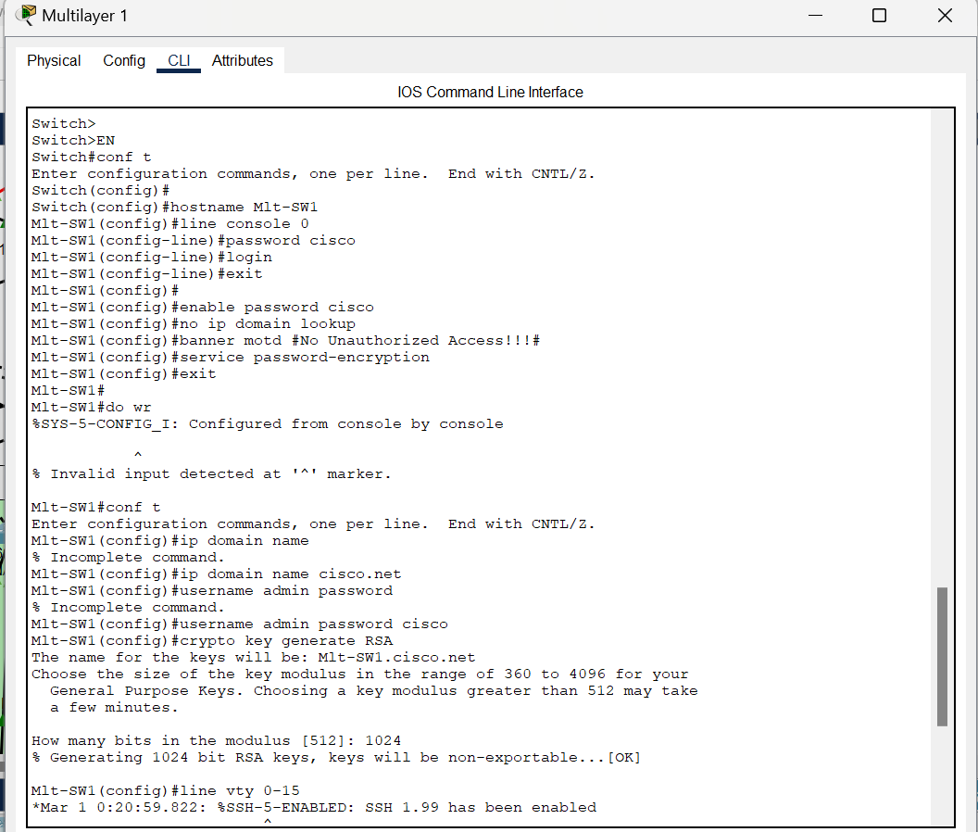
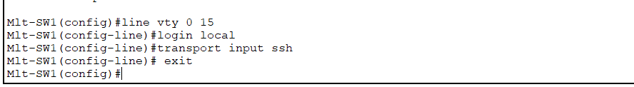
09

Device Configuration Standards

All network devices were configured using consistent standards:
- Host names assigned for easy identification
- Password encryption enabled
- Unnecessary services disabled
- Domain look-up disabled to prevent configuration delays
This improves security, consistency, and manageability.
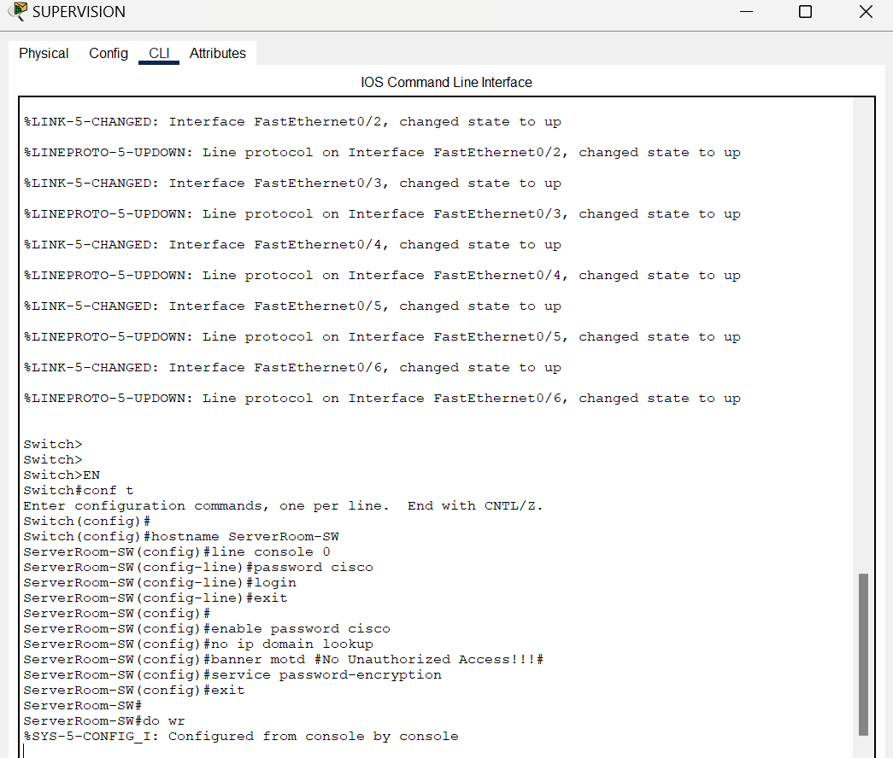

10

Testing And Verification

The network was validated through the following tests:
- VLAN connectivity testing
- Inter-VLAN routing verification
- DHCP address assignment checks
- Wireless client connectivity
- Internet access through PAT
- Routing table verification
- Security policy enforcement testing
All tests confirmed correct functionality of the network design.

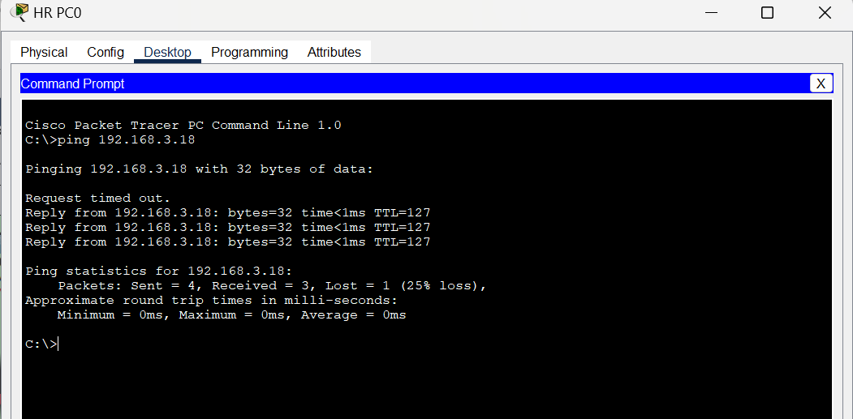

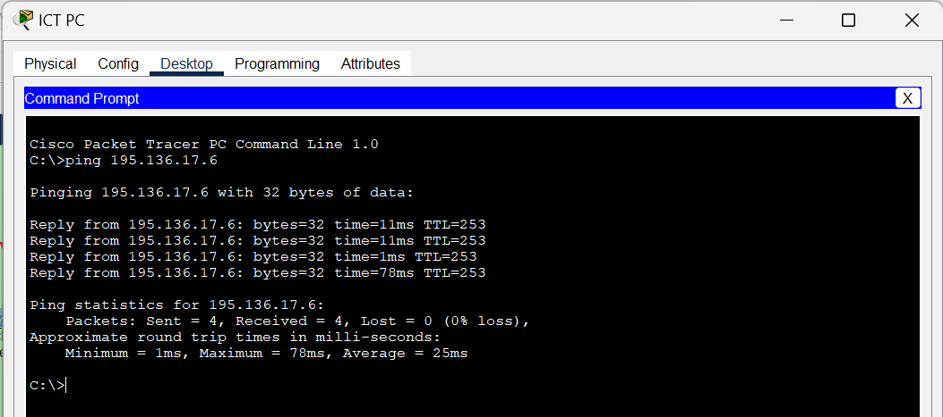
11

Conclusion

This project successfully demonstrates the design and implementation of a robust enterprise network infrastructure. The design choices ensure:
- Scalability for future expansion
- High availability through redundancy
- Efficient traffic management using VLANs
- Secure access through layered security mechanisms
- Reliable internal and external connectivity
The network is fully functional, standards-compliant, and suitable for deployment in a real-world enterprise environment.

12

Future Enhancements

- Firewall and IDS/IPS integration
- Network monitoring using SNMP and Syslog
- Load balancing across ISP links
- IPv6 implementation
- Centralized authentication using AAA servers

~~~~~~~~~~~~~~~~~~
·

